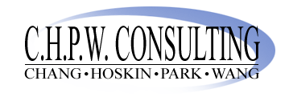

Summary Report: Cambridge Technology Partners

Management 212

Tsung-Ling Chang
Ryan Hoskin
Sun Wha Park
Feilin Wang

